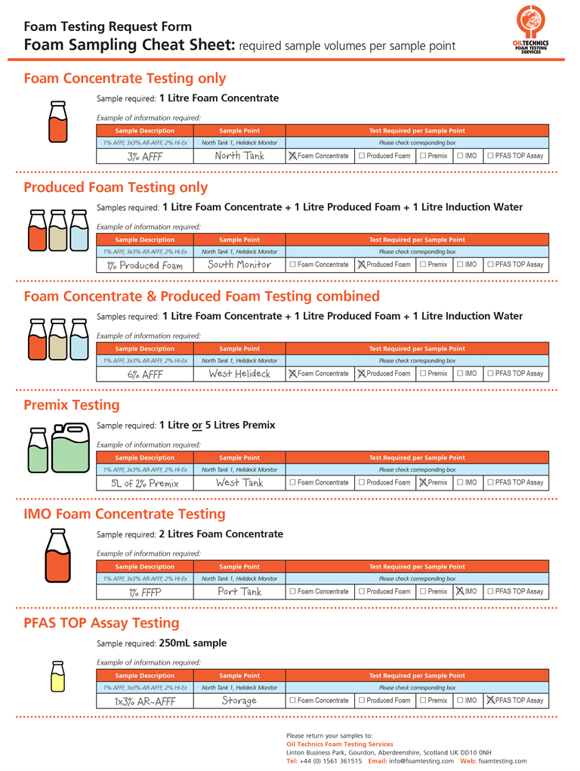

Customer Name: |  | Date:
Sample Location: |  | Quote Ref:
Company Invoicing Address: |  | Order Ref./PO No.:
 |  | Report Turnaround: | ☐ Standard (according to agreement) ☐ Express.
 |  | SDS included: | ☐ Yes ☐ No
Contact Name/s: |  | Position:
Report E-mail/s: |  | Telephone:
Additional Info/Notes |  | Are any samples C8-based | ☐ Yes ☐ No

No: | Sample Description | Sample Point | Test Required per Sample Point
Example | 1% AFFF, 3x3% AR-AFFF, 2% Hi-Ex | North Tank 1, Helideck Monitor | Please check corresponding box.
1 |  |  | ☐ Foam Concentrate | ☐ Produced Foam | ☐ Premix | ☐ IMO | ☐ PFAS TOP Assay
2 |  |  | ☐ Foam Concentrate | ☐ Produced Foam | ☐ Premix | ☐ IMO | ☐ PFAS TOP Assay
3 |  |  | ☐ Foam Concentrate | ☐ Produced Foam | ☐ Premix | ☐ IMO | ☐ PFAS TOP Assay
4 |  |  | ☐ Foam Concentrate | ☐ Produced Foam | ☐ Premix | ☐ IMO | ☐ PFAS TOP Assay
5 |  |  | ☐ Foam Concentrate | ☐ Produced Foam | ☐ Premix | ☐ IMO | ☐ PFAS TOP Assay
6 |  |  | ☐ Foam Concentrate | ☐ Produced Foam | ☐ Premix | ☐ IMO | ☐ PFAS TOP Assay
7 |  |  | ☐ Foam Concentrate | ☐ Produced Foam | ☐ Premix | ☐ IMO | ☐ PFAS TOP Assay
8 |  |  | ☐ Foam Concentrate | ☐ Produced Foam | ☐ Premix | ☐ IMO | ☐ PFAS TOP Assay
9 |  |  | ☐ Foam Concentrate | ☐ Produced Foam | ☐ Premix | ☐ IMO | ☐ PFAS TOP Assay
10 |  |  | ☐ Foam Concentrate | ☐ Produced Foam | ☐ Premix | ☐ IMO | ☐ PFAS TOP Assay
Additional sample table overleaf

No: | Sample Description | Sample Point | Test Required per Sample Point
Example | 1% AFFF, 3x3% AR-AFFF, 2% Hi-Ex | North Tank 1, Helideck Monitor | Please check corresponding box.
11 |  |  | ☐ Foam Concentrate | ☐ Produced Foam | ☐ Premix | ☐ IMO | ☐ PFAS TOP Assay
12 |  |  | ☐ Foam Concentrate | ☐ Produced Foam | ☐ Premix | ☐ IMO | ☐ PFAS TOP Assay
13 |  |  | ☐ Foam Concentrate | ☐ Produced Foam | ☐ Premix | ☐ IMO | ☐ PFAS TOP Assay
14 |  |  | ☐ Foam Concentrate | ☐ Produced Foam | ☐ Premix | ☐ IMO | ☐ PFAS TOP Assay
15 |  |  | ☐ Foam Concentrate | ☐ Produced Foam | ☐ Premix | ☐ IMO | ☐ PFAS TOP Assay
16 |  |  | ☐ Foam Concentrate | ☐ Produced Foam | ☐ Premix | ☐ IMO | ☐ PFAS TOP Assay
17 |  |  | ☐ Foam Concentrate | ☐ Produced Foam | ☐ Premix | ☐ IMO | ☐ PFAS TOP Assay
18 |  |  | ☐ Foam Concentrate | ☐ Produced Foam | ☐ Premix | ☐ IMO | ☐ PFAS TOP Assay
19 |  |  | ☐ Foam Concentrate | ☐ Produced Foam | ☐ Premix | ☐ IMO | ☐ PFAS TOP Assay
20 |  |  | ☐ Foam Concentrate | ☐ Produced Foam | ☐ Premix | ☐ IMO | ☐ PFAS TOP Assay
21 |  |  | ☐ Foam Concentrate | ☐ Produced Foam | ☐ Premix | ☐ IMO | ☐ PFAS TOP Assay
22 |  |  | ☐ Foam Concentrate | ☐ Produced Foam | ☐ Premix | ☐ IMO | ☐ PFAS TOP Assay
23 |  |  | ☐ Foam Concentrate | ☐ Produced Foam | ☐ Premix | ☐ IMO | ☐ PFAS TOP Assay
24 |  |  | ☐ Foam Concentrate | ☐ Produced Foam | ☐ Premix | ☐ IMO | ☐ PFAS TOP Assay
25 |  |  | ☐ Foam Concentrate | ☐ Produced Foam | ☐ Premix | ☐ IMO | ☐ PFAS TOP Assay
26 |  |  | ☐ Foam Concentrate | ☐ Produced Foam | ☐ Premix | ☐ IMO | ☐ PFAS TOP Assay
27 |  |  | ☐ Foam Concentrate | ☐ Produced Foam | ☐ Premix | ☐ IMO | ☐ PFAS TOP Assay
28 |  |  | ☐ Foam Concentrate | ☐ Produced Foam | ☐ Premix | ☐ IMO | ☐ PFAS TOP Assay

